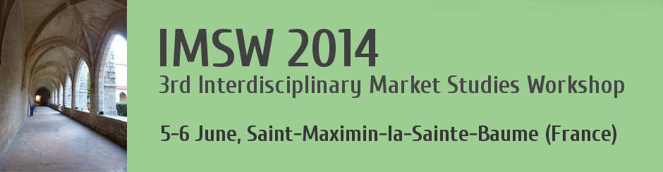 IMSW 2014: the schedule
Thursday 5 June
 | Track A | Track B
9.00-9.10 | Introduction: Kimberly CHONG, Susi GEIGER, Hans KJELLBERG, Alexandre MALLARD
9.10-9.40 | Group Session
9.45-11.15 | CM1. “Concerning” markets 1. Towards sustainable markets  Chair: Ronika CHAKRABARTI  Debbie HARRISON  Using multiple market devices-in-the-making in environmental market construction  Serafim AGROGIANNIS  Making Headways with Sustainability?: Mainstreaming Sustainability Issues in the SPP Market  Annmarie RYAN, John FINCH,  Arts Revitalizing Cities, Narratives and Performation | NS. Narratives in the construction of market actors and products  Chair: Zsuzsanna VARGHA  Bernard COVA, Robert SALLE, Lionel SITZ  The role of microdiscursive practices in shaping markets: The genericization of brand names  Anne JOURDAIN  Shaping the Art and Craft Market through narratives
11.15-11.45 | Coffe break
11.45-12.45 | Keynote 1. Jane GUYER: Transitions in Personhood and the Consumer Price Index: The Example of “Shelter”
13.00-14.00 | Lunch
14.15-15.45 | AM. Agencing markets  Chair: Bernard COVA  Daniel NEYLAND, Sveta MILYAEVA  Can Markets Solve Problems? On building a market for privacy  Suvi NENONEN, Kaj STORBACKA  Market shaping capabilities:a managerial perspective on the power to shape markets –  Vera EHRENSTEIN  Trust devices or the selective engineering of « good governance » in DRC’s forests | NP. Narratives in prescription  Chair: Luis ARAUJO  Sidonie NAULIN,  The Production of Narratives. The Case of the Gastronomic Market –  Jean-Samuel BEUSCART, Kevin MELLET, Marie TRESPEUCH  OCR in the Restaurant Industry: An Ambivalent Takeover.  Joanne ENTWISTLE  Knowing and sensing in high fashion retailing
15.45-16.15 | Coffe break
16.15-17.45 | CM2. “Concerning” markets 2. Value and values in markets  Chair: Guus DIX  Domen BADJE, Pilar ROJAS-GAVIRIA  Investigating Hybrid Transaction Networks: The Case of Philanthropic Crowd-Lending  Rebecca REUBER, Anna MORGAN-THOMAS,  Communicating moral legitimacy through socio-material practices –  Claes-Fredrik HELGESSON  Agencing in tangled situations: The case of dividing restaurant bills among friends. | F1. Framing the consumer as a market subject 1.  Chair : Jean-Samuel BEUSCART  Trine PALLESEN, Rasmus Ploug JENLE,  Remaking the Elasticity of Consumer Wants  Alain NADAI, Catherine GRANDCLEMENT,  Smart grids demonstration and the responsive electricity consumer  Johan NILSSON  ”We can know it for you wholesale – Market researchers as market-makers”
17.45-20.00 | Break
20.00 | Dinner
Friday 6 June

 | Track A | Track B
8.30-10.00 | DA. Markets as dynamic agencements  Chair: Winfred ONYAS  Jeppe Trolle LINNET  In Defense of Context: Problematizing "emergence" as an analytical dogma  Céline CHOLEZ, Pascale TROMPETTE  ‘Economic Circuits’ :A Sociology of day-to-day market arrangements. The small-scale economic fish circuit in Madagascar  Ronika CHAKRABARTI, Katy MASON  Market Empowerment - for Six Days Only: An exploration of the empowerment of market actors to constitute, perform and dismantle Durga Puja Markets | MS. The construction of market subjects - Empowerment  Chair: Catherine GRANDCLEMENT  Robert KNEGT  Has market subjectivity been created in legal practices?  Elizabeth GULLEDGE, Barbara TOWNLEY, Philip ROSCOE,  Acquiring an economic habitus: the role of calculation in learning ‘the rules of the game’  Guus DIX  Charting human performance: Gantt’s Man Record Chart as a material power/knowledge device
10.00-10.30 | Coffe break
10.30-11.30 | NM1. Narratives in market making 1.  Chair : Phil ROSCOE  Gillian HOPKINSON, Mohammed CHEDED,  Ante-narrative struggle in market making.  Kristian BONDO HANSEN  Narrating the Financial Market: Contrarian Speculation, Crowd Psychology and Popular Culture | NM2. Narratives in market making 2.  Chair: Daniel NEYLAND  Luis ARAUJO, Katy MASON, Martin SPRING  Expectations and Foresight as Market Shaping Devices: the case of driverless cars –  Thomas BEAUVISAGE, Kevin MELLET  Narratives and quality conventions in the market for social media marketing
11.35-12.35 | Keynote 2. Don SLATER: Ambiguous goods as market devices: the case of smart homes and connected houses
12.45-13.45 | Lunch
13.45-15.15 | MD. Numbers, graphs, algorithms as market devices  Chair: Debbie HARRISON  Stefan SCHWARTZKOPF  Give me a Rating Scale and I will create a Market around it: How Numbers Make and Unmake Markets for Advertising Communications  Donald MACKENZIE  A Sociology of Algorithms: High-Frequency Trading, Boundary Work and History’s Traces  Gian Marco CAMPAGNOLO, POLLOCK Neil, WILLIAMS Robin  Simple graphs in business settings | F2. Framing the consumer as a market subject 2.  Chair : Pascale TROMPETTE  Zsuzsanna VARGHA  Conversation stoppers: constructing consumer Attitudes to Risk in UK wealth management  Winfred I. ONYAS, Luis ARAUJO  The making of a Mobile Money market agencement: examining the MTN Uganda platform –  Oskar KORKMAN, Suvi NENONEN, Kaj STORBACKA  The impact of consumption practices and objects on market dynamics: Case photography and beer
15.15-15.35 | Concluding group session
15.40-16.15 | Workshop conclusion
16.30 | Bus departure for Aix TGV railway station and Marseilles Provence Airport

